 | June 8th Mtg  Confirmation | June 8th Mtg  Attended | June 8th Minutes
Allan Gordon, Greenstone Metis Council | No | No |  | Having problems connecting
Bernie Baillargeon, Bear Management & Baitfish | No | No
Blair Binnendyk, Forest Management Ogoki | Tentative | No
Bob Baycroft, Fishing/Hunting Interest | Yes | Yes
Brian Desrochers, Trapping | Yes | Yes
Deanna Hoffman, Forest Management Kenogami | Yes | Yes | Good
Ed Hoffman, Forest Industry | Yes | Yes
Eileen Johnson, Local Business | Tentative | No
Evan Armstrong, General Public | Yes | Yes
James McPherson, Municipality of Greenstone | Yes | Yes | Good
Jason Booth, Remote Tourism | Tentative | No
John Espinola, Road Accessed Tourism | No | No | Good
Ken House, Cottaging | No | No
Ken Stevens, Crown Land Recreation | No | No
Rob Haslam, Naturalist | No | Yes | Good
Vacant, Chamber of Commerce
Vacant, Aboriginals
Vacant, Mining
Alternates:
Brent Henley , Remote Tourism | Yes | No
Clarke Brown, Fishing/Hunting Interest | Yes | Yes
Kellie Chippett, Forest Industry | Yes | Yes
Sean Antonson, Trapping | Late | Yes
Steve Thuerig, Naturalist | Tentative | Yes
Tanya Couture, Crown Land Recreation | No | No
Taylor Hall, Forest Management Kenogami | Yes | Yes
Vaughn Arsenault, Cottaging | Yes | Yes
Vacant, Local Business
Vacant, General Public
Vacant, Aboriginals
Vacant, Road Accessed Tourism
MNRF:
Amie Nephin, MNRF LCC Liaison | Yes | Yes | Good
Jamie-Lee Koroscil, MNRF LCC Logistics | Yes | Yes
Charlotte Bourdignon, MNRF Forester, Kenogami | Yes | Yes | Good
Vacant, MNRF Forester, Ogoki
Philip Wilson, MNRF Biologist | Yes | Yes | Good
Leal Strain, MNRF District Supervisor | Yes | Yes
Guests:

- Call to Order & Introductions
- MNRF- Leal, Amie, Charlotte, Philip, Jamie-Lee
- Bob Baycroft- Hunting and Fishing Interest
- Deanna Hoffman- Nedaak Forest Management Kenogami
- Ed Hoffman- Forest Industry
- Evan Armstrong- General public
- Jamie McPherson- Municipality of Greenstone
- Rob Haslam- Naturalist
- Clarke Brown- Hunting and Fishing Interest alternate
- Taylor Hall- Nedaak Forest Management Kenogami alternate
- Vaughn Arsenault- Cottage/ Camp owners alternate
- Sean Antonson- Trapping alternate
- Kellie Chippett- AV Terrace Bay – Forest Industry alternate
- Brian Desrochers- Trapping
- Steve Thuerig- Naturalist alternate

- Review of Agenda
  - Any additions/ deletions? No

- Approval of Previous Minutes (April 13th Mtg)
  - Any corrections? No
  - Motion to approve- April 13th minutes by Evan Armstrong, seconded by Rob Haslam

- Business Arising from Previous Minutes (Review of action items from April 13th Mtg)
  - Forest Stewardship Council (FSC)- Group meeting May the 4th- Deanna‘s summary on meeting: Went over World Wildlife fund analysis as well as looked at things that are on the landscape during FMP planning process in terms of parks, different AOCs, and identified few potential areas to look at to increase the last 1% of conservation area network required to meet FSC standards. Still need to talk to other First Nations communities as well as NGOs, this was first step in that. Next meeting with GANRAC will be fall.
    - Charlotte says this still needs to get officially vetted through MNRF prior to any further public engagement. Evan asked if process would occur before the fall? Charlotte does not know
  - Previous February minutes were deferred- clean version sent out today by Evan
  - Amendment 006- 200 m AOC to be cut upon trappers request due to the trapper’s perception of a potential fire hazards- Is there anything new on item? Taylor Hall met with trapper and representative from AV. They confirmed he wanted trees in area of concern cut and harvest has been completed, trapper is happy with work
  - Administrative Amendment- new sign- Taylor Hall- Sign has been installed at corner of the block road and Rail line, so that you can see it from where you would turn off. Road still must be ditched on the loop road, but it’s not a good road to begin with and AV said will ditch it when they have road building equipment up in the block (Update: has now been ditched)
  - Kellie indicated they would be able to answer question soon- any update? Deanna- They submitted an estimate of where they think they will be to Nedaak and have forwarded to Charlotte. They have tentative blocks and time periods of where they’re going to be in this annual work schedule year out of the whole list. As it stands right now, they gave a preliminary listing from annual work schedule of where they’re operating
  - Update on the Wawong Lake stocked fish situation- Evan met with Phil and Leal by phone and they committed to getting fish samples- They were collected yesterday and turned over to NDMNRF- 10 splake sampled- all 10 had traces of parasites- Phil has sent off today and will provide a copy of report
  - Anything else from previous minutes?
    - Rob Haslam- Under amendment process there was a road back between Keane Lake and Toupee Lake crucial port on the trip from Dickison back to Geraldton. Rob was initially not happy when he saw it the first-time during construction. He revisited the site after completion and was happy with what he saw. They provided access to trail on either side of the road with a gravel ramp. The road itself is not huge. We usually don’t like roads going over portages because it destroys the concept of the illusion of wilderness that we’re looking for but the invasion of the road itself was minimal. There were some questions that came to mind regarding prescribed buffers because they were within 100 m to the road the buffer was basically nothing. As it extended back on the one side it was ~30 m at most points. Port wasn’t completely ruined- Buffers are something that can be worked on in future.
      - Deanna stated that this was done under old plan before discussion of new buffers. The construction hit just before changes came into place

- Correspondence – (Evan)
  - Evan did not receive any correspondence – forwarded Nedaak newsletter to all

- Budget - (Evan)
  - Sent a new version out today- received cheque from MNRF for brochures, also received $500 from Municipality
  - Brochures were finalized and approved for printing but on 17th of May got an email from Times Star saying the price was going to change because they must change the way they print them, and it will cost more money. We have money sitting from the town and NDMNRF for this but waiting on Times Star
  - Move to accept budget by Evan - Second is Ed Hoffman

- New Business
- OPG Long Lake Water Management Plan Presentation: (Philip)

- Going to focus presentation on Lake Trout because we have previous history of fishing and assessments on the lake and some current examples
- Lake Trout monitoring population in Long Lake- Has upfront material applicable to water management plan. Kenogamisis, Long Lake, Chipman, and Aguasabon River form the Aguasabon River System water management plan. Which was developed as an account for historical damming in the 40s to redirect the flow of Long Lake which used to flow north into the Hudson Bay low land and watershed to direct it south for power generation and log transportation in the early days of forest logging and tugboat logging.
- Featured Effectiveness Monitoring in WMP was identified in early stages of water management plan. First Nations and licenced anglers noticed a decline in Lake Trout. In 2006 there was an MNR protocol used by Anishinabek / Ontario Fisheries Resource Centre, which they achieved to a certain degree successful netting. Some recommendations were to generate a population assessment to achieve some effectiveness monitoring as well as sampling frequency with recommendations of redoing the sampling within a 10-year cycle.
- Primary objectives of the work- have recently conducted a similar Summer Profundal Index Netting (SPIN) assessment to compare that to the 2006 estimate to detect changes in biological recruitment as well as to evaluate the biological integrity of the population through genetic sampling. Then monitor the long-term effects on the population from water draw downs at certain periods of the year, with the purpose of making recommendations to improve the overall Lake Trout reproductive cohorts and try to raise water at certain times of the year when appropriate.
- Data collected included ageing structures- Scales and otoliths (ear bone), weight, fork and total length genetic samples, sex, and gonad conditions to access stage of maturation.
- Prelim Results- Relative Standard Error is a way to access how confident you can be in your data. 5%- 10% is good quality. Protocol says if you can achieve 20% relative standard error, then additional sampling is not necessary. Were able to achieve 20% in this study. Compared to 2006 which was 23%. Does not look like much of a difference but does account for some variability in population number of those fish.
- Another survey completed is a loon survey. Data shows that when water is rapidly increased earlier in year then it floods loon nests and there are no young produced. If water is gradually increased, then nest success probabilities increase.
  - James asked if from your draft data can you confirm that the scheduled lowering and raising lake in the fall is making a difference? Phil stated that they try to bring levels down in fall to 312.4m which forces lake trout to spawn lower in the water column and then gradually increase them after the 1 -15 Oct. One recommendation was to increase water levels earlier in winter, so the ice sheet does not crush the eggs while they are developing.

- Personal Use Permit Changes Presentation: (Charlotte)
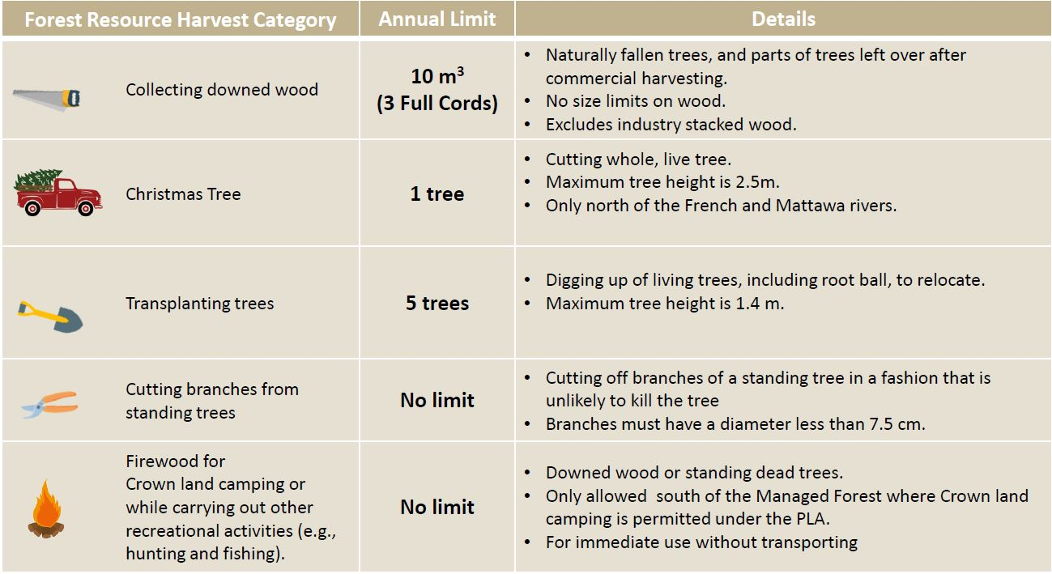
- Question from Phil- There’s a section in Kenogami FMP that says if wood is left behind by forest industry once operations are complete and they are no longer going into that block (block is closed), it says that the wood is available to the public to take. Does the new Rules in Regulation potentially contradict this now?
  - Charlotte- Free use will not be wood left at roadside that was intended to be moved. If wood is scaled, then an authorization must be applied for. If no scale marks a fee would apply. Intention is to prevent wood theft and potential conflict with forest industry.
- Resources Available to the public:
  - Ontario.ca Webpage: https://www.ontario.ca/page/using-wood-crown-land-personal-use
  - CFSA and General Regulation: https://www.ontario.ca/laws/regulation/950167
  - Environmental Registry Decision Posting: https://ero.ontario.ca/notice/019-4922
- Question from Phil- What if you have multiple residence? Can I cut 3 bush cords at my house and then cut 3 bush cords at my camp? Charlotte does not have an answer yet and will revisit next meeting
- Question from Brian- Will there be publications available for the public to pick up at MNRF offices to help decide if they need authorization? Charlotte indicated that they will be directed to Ontario.ca website (link is above) and that once October 1 comes around there might be more added to website.

- GreenFirst Forest Products amendment request to upgrade a road on the Kenogami forest to stockpile wood harvested from the Hearst Forest on the Clavet Rd (Taylor)
  - GreenFirst Forest Products (GFFP) is looking to upgrade 4.1 km of road on Kenogami Forest so that they can haul from where wood will be harvested on the Hearst Forest down the Spur Line road then haul it through this updated road to the Clavet Road and then down to the highway. Looking to bring this old road into the FMP. Looking to update late summer/early fall for use in winter.
  - Will also be revising wood storage yards into AWS. They were approved in amendment 004 but were not expected to be needed this year.
  - Looking for LCC classification on whether this is minor, administrative or a major amendment to upgrade this road for GreenFirst.
    - Evan asked if you will be contacting all the trappers, First Nations, and BMA operators? Taylor advised that yes they will be contacted
    - Charlotte asked if the road already exists? Taylor responded that yes, they would have to do a little bit of clearing and brushing to make it big enough but would build right on the existing roadbed
    - Steve asked if when you say upgrade is that upgrade to a haulable standard or looking to move it to a primary branch class? Just to make it haulable standard
    - Steve-Existing Road? Taylor let him know that yes- It was in previous FMPs so the roadbed and base are there but it is not listed as a road in the layers of this plan
    - Steve stated that based on explanation, this sounds administrative- motion for that, seconded by Evan with understanding of notifications he mentioned. Carried Administrative Amendment.

- Ogoki Operations Update (Blair)
  - Anyone available to talk to since Blair is not here? Charlotte- they do have a tree plant planned for this year

- Nedaak Operations Update (Taylor)
  - Tree plant started June 1. It is being done by Haveman Brothers going to plan to plant 3.6 million trees. Expected completion date of July 8th
  - Mechanical site prep in Lydia, Miriam and Anderson
  - Put in start of herbicide plan. Will be the same as last year. Looking to start on Aug 2 and end on Sept 17

- AV Terrace Bay Operations Update (Kellie)
  - Still working around top end of the Goldfield
  - Still working Blueberry, Waba, Twin Lakes intersection
  - Had the trucks shut down because of spring but they are back up and running now
  - Hauling from the Catlonite 76 harvesting
  - Going to be hauling from the north end of the Goldfield as well

- Columbia Forest Products Operations Update (Ed)
  - Harvest at Kowkash bridge block. Expecting to be done approximately July 1st started on June 6th- starting to move product out and everything is going good

- Open Discussion
  - GDC update- Deanna- GDLP is harvesting at Blueberry block km 28, hauling out of there as well and doing road building. Also building, and refining road at Jackfish. Moving into Little Wolf and doing some road harvesting there in the next couple of weeks.
  - Steve- Any updates on the bridge on Catlonite- access blocked off and must go around. Charlotte- Doesn’t think anything in works yet, a lot of negotiations in background before movement on that
  - Leal- update on staffing- Tara Rooney has moved on to position with private sector- currently trying to fill her Ogoki Forester position. Also losing technician Eric Wilcox to Pembroke in IRM position.
  - Phil- If anyone comes across anything they want analyzed or further information on, we have a good system set up with the University of Guelph. So, if you bring a sample of something you’re concerned about (tissue of fish, any wildlife abnormalities or parasites, funky odours that can indicate infection) contact Phil and we can get it sent in. Results come quickly, and they provide a necropsy result report that we can provide back to you.

- Next Meeting: September?
  - We take the summer off and usually come back to September or October.
  - Tentative date for September 21st, 2022.

- Adjournment
- Future Agenda Topics: LCC Mandate; Aboriginal Agenda; Far North Act & Community Based Land Use Plans.
- Ed Hoffman moves to adjourn at 8:08pm, seconded by Bob Baycroft

